Beijing Internet Court

Civil Judgment

(2019) Jing-0491-Min-Chu No. 1957

Plaintiff: Tencent Technology (Shenzhen) Co. Ltd., domiciled in 35/F, Tencent Building, Keji Middle 1st Road, SHIP, Nanshan District, Shenzhen, P. R. C. China

Legal representative: Ma Huateng, Chairman and General Manager

Attorney: Yan Chunde, lawyer of Unitalen Law Office Shanghai Branch.

Attorney: Zhou Dandan, lawyer of Unitalen Law Office.

Plaintiff: Shenzhen Tencent Computer Systems Co., Ltd., domiciled in 5-10/F, FIYTA High-tech Building, Gaoxin South 1st Road., SHIP, Nanshan District, Shenzhen

Legal representative: Ma Huateng, General Manager

Attorney: Yan Chunde, lawyer of Unitalen Law Office Shanghai Branch.

Attorney: Wang Jiayu, lawyer of Unitalen Law Office.

Defendant: Beijing Qingshu Network Technology Co. Ltd., domiciled in Room A-0812, 2/F, Building# 3, Courtyard# 30, Shixing Street, Shijingshan District, Beijing.

Legal representative: Xia Yan, Executive Director.

Attorney: Sun Yueheng, lawyer of Beijing Jinshi Law Office.

In respect of the dispute over the infringement of the right to communicate works through information network and unfair competition between the plaintiffs Tencent Technology (Shenzhen) Co. Ltd. (hereinafter “Tencent Technology”) and Shenzhen Tencent Computer Systems Co., Ltd. (hereinafter “Tencent Computer”) and the defendant Beijing Qingshu Network Technology Co. Ltd. (hereinafter “Qingshu”), after the case was accepted, the Court applied ordinary procedures according to law and convened a public court session. Yan Chunde and Zhou Dandan, the attorneys of the plaintiff Tencent Technology, Yan Chunde and Wang Jiayu, the attorneys of the plaintiff Tencent Computer, and Sun Yueheng, the attorney of the defendant Qingshu, participated in the court session online through the digital litigation platform of the Court. This case is decided now.

The plaintiffs Tencent Technology and Tencent Computer jointly pray as follows: 1. The defendant shall immediately cease infringing the copyright of the plaintiffs’ fine art work involved in the case; 2. The defendant shall immediately cease unfair competition; 3. The defendant shall publish a statement in respect of its act of unfair competition for a month in a prominent position on the homepage of its official website (www.meetqs.com) to eliminate the impact on the plaintiffs; 4. The defendant shall be ordered to compensate the plaintiffs for their economic losses and reasonable expenses totaling RMB 4.5 million, of which reasonable expenses include attorney fees of RMB 90,000 and notary fees of RMB 4,896, a total of RMB 94,896.

Facts and reasons: On December 20, 2016, Tencent Technology completed the fine art work “WeChat Red Packet 2017 New Year Edition”, thus enjoying the copyright of the WeChat Red Packet Chat Bubble (the pages before and after the red packet is received) and the WeChat Red Packet Opening Pages (the pages before and after tapping) (collectively “WeChat Red Packet Chat Bubble and Opening Pages”, see Annex 1.1). On January 10, 2011, Tencent Technology authorized Tencent Computer to operate the WeChat app and its upgraded versions, and granted the latter exclusive rights to use the corresponding fine art work. The WeChat Red Packet Chat Bubble and Opening Pages were used in the WeChat app. Since the WeChat app was put on the market, it has quickly accumulated hundreds of millions of users for the plaintiffs, and has formed a very high visibility and influence among the relevant public. Once the WeChat Red Packet and other features provided in the WeChat app were launched, they gained widespread response and popularity. The plaintiffs found that the defendant developed and operated the app ChuiNiu and provided download and installation services on its official website (www.meetqs.com) and several mobile app download platforms. The ChuiNiu app provides red packet sending and receiving services. The Chat Bubble and opening pages of its three digital red packets (see Annex 1.2) are substantially similar to the plaintiffs’ existing fine art work WeChat Red Packet Chat Bubble and Opening Pages. The defendant’s act infringed the plaintiff’s right of communication through information network in respect of the above-mentioned work art.

The red packet sending page, chat bubble, opening pages and detail checking page of WeChat Red Packet (collectively, relevant pages of the WeChat Red Packet, see Annex 2.1) and the overall page of WeChat (including a search bar, a list of friend chats, a navigation bar, a chat page, icons, etc.) (See Annex 2.1) are the plaintiffs’ decorations of certain influence. The defendant is the operator of the same-type product and services. The relevant pages of the three digital red packets on the ChuiNiu app (see Annex 2.2) copy and imitate the whole process design, software interface and icon design of the WeChat Red Packet in an overall way, which can easily cause confusion or misrecognition by the relevant public and should be regulated by applying the first paragraph of Article 6 of the *Anti-Unfair Competition Law of the People’s Republic of China* (referred to as the “Anti-Unfair Competition Law”). If the Court believes that the clause is not applicable, the plaintiffs also request to apply the fourth paragraph of Article 6 and Article 2 of the Anti-Unfair Competition Law in sequence. Therefore, the defendant shall bear corresponding civil liability for its infringement of the plaintiffs’ copyright and unfair competition.

The defendant Qingshu defended as follows: first, Tencent Technology is not an eligible plaintiff. Tencent Technology has authorized Tencent Computer to exercise the rights in the WeChat Red Packet Chat Bubble and Opening Pages and the right to operate the WeChat app. Nor does it have the evidence to prove Tencent Technology is entitled to the proceeds from the WeChat Red Packet Chat Bubble and Opening Pages involved in the case or has the right to operate the WeChat app. Hence, the company cannot claim rights in respect of the copyright and unfair competition of the WeChat Red Packet Chat Bubble and Opening Pages involved in the case. Second, regarding the copyright ownership and alleged infringement. 1. The WeChat Red Packet Chat Bubble and Opening Pages are not original. The design of the digital red packet comes from real red packets in life, and is limited by the inherent packet structure, color and other characteristics of real red packets. The space for creation is very limited. Compared with real red packets, it is hardly distinctive and thus not original. 2. Before the plaintiff registered the work, a large number of digital red packets that are identical with or similar to the WeChat Red Packet Chat Bubble and Opening Pages had been published. The work registration certificate alone cannot prove that the plaintiff has the copyright. 3. With limited space for red packet creation, there are certain differences between the relevant pages of the digital red packets used by the defendant and the WeChat Red Packet Chat Bubble and Opening Pages claimed by the plaintiff. So the defendant has not committed any infringement. Third, regarding the alleged unfair competition. 1. The red packet sending and receiving function of the ChuiNiu app is conspicuously marked with the Chinese characters “支付宝红包 (Alipay Red Packet)” and “云红包 (Cloud Red Packet)”, which clearly shows to users that the service is provided by the defendant. In addition, the defendant never promotes in any form that the ChuiNiu app developed by it has any connection with the WeChat app. So the relevant public will not confound or misrecognize the two. 2. The WeChat Red Packet is not an independent product or service. It is only a service module of the WeChat app. So the relevant pages of the WeChat Red Packet cannot constitute decoration with certain influence. The overall page of WeChat will not be shown when a user is using the WeChat Red Packet. Hence, the overall page of WeChat does not constitute decoration with certain influence. 3. Given the nature of digital red packets, the logical settings of their sending pages, opening pages and detail pages, as well as the page settings of shape and color, are limited by the nature and use of digital red packets. Therefore, the plaintiffs’ request to order the defendant to stop using the red packets based on the claims that the red packets used by the defendant have the aforementioned settings and patterns is a monopolistic act that fundamentally denies others’ right to operate red packets. 4. Under the law of “download and install first, then open and use”, it is impossible for users to confound or misrecognize the ChuiNiu app or its red packet sending and receiving functions with the Tencent or WeChat app when downloading, installing and using the app. The defendant’s development and use of the application does not violate the principle of good faith and universally acknowledged business ethics for the development and use of the software. Its act is proper and does not constitute unfair competition. In view of the above, the defendant requests the Court to dismiss all the plaintiffs’ claims.

The parties submitted evidence based on their claims. The Court organized evidence exchange and cross-examination among the parties, on which basis the following facts are ascertained.

**I. Facts about the Plaintiffs and the Defendant**

**(I)Facts about the Plaintiffs**

Tencent Technology, established on February 24, 2000, mainly engages in the development of computer software and hardware technologies, sales of self-developed software; computer technology services and information services, etc.

Tencent Computer, founded on November 11, 1998, mainly engages in the design, technological development and sales of computer software and hardware (excluding state controlled and franchised items and restricted items); database and computer network services, etc.

On April 9, 2012, the National Copyright Administration issued the Computer Software Copyright Registration Certificate numbered R. Z. D. Z. No. 0395032. The software name is Tencent WeChat Software [abbr.: WeChat] 3.5. The copyright owner is Tencent Technology. Both the completion date and the first publication date are January 21, 2011. The way of rights acquisition is original acquisition. The scope of rights is all. The registration number is 2012SR026996.

On January 10, 2011, Tencent Technology issued a letter of authorization as the copyright holder of the WeChat app to authorize Tencent Computer to operate the above application and its upgraded versions, and meanwhile, to grant the copyright of the above application and its upgraded versions (including but not limited to the copyright of related elements and works used in the application) to Tencent Computer for exclusive use without excluding the use by Tencent Technology. Tencent Computer may remedy against the infringement of the above-mentioned legal rights by itself or jointly with Tencent Technology by litigation and non-litigation means. The authorization expires when the authorizer withdraws this authorization. So far, Tencent Technology has not withdrawn its authorization.

During the trial, the defendant asserted objection to the authenticity of the above letter of authorization. Regarding the authenticity of the letter of authorization, the Court believes that first, the two parties involved in the authorization letter are the plaintiffs in the case, and they both recognize the authenticity of the authorization letter; second, based on the actual performance, the WeChat app and related elements and works are actually operated and used by Tencent Computer, which can prove that there is indeed a relationship between the two plaintiffs in respect of the licensed use of works; finally, the defendant did not submit contrary evidence to deny the authenticity of the authorization letter. Therefore, the Court admitted the above authorization letter and confirmed the relationship between the two plaintiffs in respect of the licensed use of works.

**(II) Facts about the Defendant**

Qingshu, incorporated on December 6, 2017, mainly engages in technology development, technology consulting, technology services, technology transfer, and technology promotion; data processing (except bank card center in data processing and cloud computing data center with PUE value above 1.5); computer system services; basic software services; application services; Internet cultural activities; Internet information services. The company is the developer of the ChuiNiu app (for iOS and Android) and the sponsor of Qingshu Technology’s official website (its domain name is meetqs.com).

The copyright owner of the ChuiNiu app is the defendant. The registration number is 2018SR010307, and the registration date is January 4, 2018. During the trial, Qingshu stated that the ChuiNiu app was mainly used for social chatting and purchase of game equipment.

The above facts can be supported by the notarial certificates (2019) Y. G. G. Z. No. 022649, (2018) S. Q. Z. Z. No. 026015, No. 029770, No. 029778 and No. 029779, the authorization letter, the parties’ statement and trial transcripts submitted by the plaintiffs.

**II. Facts about the Plaintiff’s Claim for Copyright of Relevant Pages and That Relevant Pages Constitute Decoration of Certain Influence**

On March 6, 2017, Tencent Technology registered the work “WeChat Red Packet 2017 New Year Version”. The registration number is G. Z. D. Z.-2017-L-00363803. The author and copyright owner is Tencent Technology. The work category is other. The completion time is December 20, 2016, and the time of first publication is not recorded. It includes the Sending Page of the WeChat Red Packet, the Opening Pages of the WeChat Red Packet before tapping (there is the Chinese character “開(open)” in the middle) and the WeChat Red Packet Detail Checking Page.

The page of the WeChat Red Packet Chat Bubble before the red packet is received that includes the Chinese characters “点按领取(tap and receive)” was created on January 20, 2015. The page of the WeChat Red Packet Chat Bubble before the red packet is received that includes the Chinese characters “查看红包(check out the red packet)” with a small red packet pattern on the right and the Chinese characters “恭喜发财，大吉大利(good luck and fortune)” on the left was created on April 1, 2016. The page of the WeChat Red Packet Chat Bubble before the red packet is received that includes the Chinese characters “查看红包(check out the red packet)” was created on March 21, 2017. The page of the WeChat Red Packet Chat Bubble after the red packet is received was created on March 21, 2017

The WeChat update logs “WeChat 6.1 for iOS newly released in January 19, 2015” and “WeChat 6.1 for Android newly released in January 20, 2015” both included “The WeChat red packets can be sent from the tool bar now” and were attached with the page of the WeChat Red Packet Chat Bubble before the red packet is received that includes the Chinese characters “领取红包(receive the red packet)”, the WeChat Red Packet Opening Page before tapping (there are Chinese characters “拆红包（open the red packet) in the middle) and the overall page of WeChat.

On January 20, 2017, PConline published an article “Why Do You Want to Poke at the First Sight of a WeChat Red Packet?”, which analyzed the design and creation concept of the WeChat Red Packets and displayed the page of the WeChat Red Packet Chat Bubble before the red packet is received that includes the Chinese characters “领取红包(receive the red packet)”. On February 28, 2015, XP85.com published an article “What If I Can’t Grab Red Packets”, which showed the page of the WeChat Red Packet Chat Bubble before the red packet is received that includes the Chinese characters “领取红包(receive the red packet)” and the WeChat Red Packet Opening Page after tapping.

The defendant raised objection to the authenticity to the above evidence. The Court holds that the authenticity of the computer screenshots of the corresponding creation drafts, the screenshots of the WeChat update logs, and the online articles, which were submitted and notarized by the plaintiffs, cannot be denied if there is no evidence to the contrary.

The above facts can be supported by the notarial certificates (2018) Y. G. G. Z. No. 178061, No. 193231 and No. 193213, and (2018) S. Q. Z. Z. No. 029717, the parties’ statement and trial transcripts submitted by the plaintiffs.

**III. Facts about the Defendant’s Alleged Infringement**

The ChuiNiu Red Packet (i.e. Pocket Money Red Packet) in the ChuiNiu app (for iOS and Android) includes: the sending page of the ChuiNiu Red Packet, the pages of the ChuiNiu Red Packet Chat Bubble before and after the red packet is received, the ChuiNiu Red Packet Opening Pages before tapping (there is a Chinese character “開(open)” in the middle) and after tapping, the detail checking page of the Alipay Red Packet, and the overall page of the ChuiNiu app.

The Alipay Red Packet and the Cloud Red Packet in the ChuiNiu app (for iOS and Android) include: the sending page of the Alipay Red Packet, the pages of the Alipay Red Packet Chat Bubble before and after the red packet is received, the Alipay Red Packet Opening Page before tapping, the detail checking page of the Alipay Red Packet, the sending page of the Cloud Red Packet, the pages of the Cloud Red Packet Chat Bubble before and after the red packet is received, the Cloud Red Packet Opening Page before tapping, the detail checking page of the Cloud Red Packet, and the overall page of the ChuiNiu app.

The above facts can be supported by the notarial certificates (2018) S. Q. Z. Z. No. 029778, No. 029779, No. 029770 and No. 029771, the parties’ statement and trial transcripts submitted by the plaintiffs.

**IV. Facts about the Defendant’s Defense**

Baidu Experience, Chaoshan News and other websites have published a number of articles, including “How to Use Alipay Red Packet?” (The publication time is not shown), “How to Receive Red Packets in Alipay Wallet” (updated on December 2, 2014), “How to Grab Red Packets from Alipay” (updated on February 11, 2015), “Jieyang City, Highest Average Amount of Red Packets Sent in Guangdong, Three Cities in Chaoshan Area Rank Top Ten” (published on February 27, 2015), “How Does iOS 11 Send Red Packets to Alipay with iMessage” (published on September 20, 2017), “How to Use JD Red Packets and How to Use Grabbed Red Packets on JD” (updated on October 26, 2014), “Which is the Best App for Grabbing Red Packets? Apps Recommended for Grabbing Red Packets in 2016” (published on December 28, 2015), “How to Send Red Packets on MoMo? Here are the Methods!” (published on January 14, 2016), and “How to Use Traffic Bank (流量银行) to Send Red Packets” (updated on November 27, 2014). There is the app “Top Speed Gadget for Grabbing Red Packets（极速抢红包神器）” in IQIYI app store. The digital red packet sending and receiving pages are shown in the above screenshots, and there is the character “開(open)” on some of these pages. On websites including 58pic.com, ooo.pic.com and cxtuku.com, there are the materials and design drawings of the relevant red packets. On August 13, 2014, the WeChat official account “Shenyang and Liaoning Consumption Lifestyle” (WeChat ID: sctiyanying) published the article “3C Experience Camp Joins Hands with DiDi to Send 100,000 Red Packets for Free”, in which the red packet sending and receiving pages of the relevant packets are shown.

The above facts can be supported by reliable time stamp authentication certificates and webpage screenshots, statements of the parties and trial transcripts submitted by the defendant.

**V. Facts about Damages and Reasonable Expenses Claimed by the Plaintiffs**

**(I) Facts about the WeChat Red Packet Chat Bubble and Opening Pages, relevant pages of the WeChat Red Packet, and visibility and usage volume of the WeChat overall page**

On February 21, 2018, Tencent.com published the article “28 Million Users Play Mini Game Tiaoyitiao in the Same Hour at Peak during Spring Festival”, which specifies that from the eve to the fifth day of the Chinese Lunar New Year of 2018 “768 million users used WeChat red packets to deliver new-year greetings. The total number of people sending and receiving red packets increases by about 10% compared with last year.” “The Most Complete Data: Take a Look at the Rooster Year’s Eve from the Perspective of WeChat Red Packet”, an article published on Tencent.com on January 28, 2017, said on January 27, 2017 “A total of 14.2 billion WeChat red packets were sent and received, up by 75.7% compared to the Year of the Monkey. At 24:00, the number of red packets sent and received peaked at 760,000 per second”. Sohu Business published the article “WeChat Red Packet Goes Viral, Ushering in the Mobile Payment Year 2014” on February 25, 2014. According to the article “32.1 Billion Red Packets Sent and Received during the Spring Festival of the Year of the Monkey. Spring Festival Becomes the Home Ground of WeChat Red Packets” published by Tencent.com on February 13, 2016, during the Spring Festival (from the eve to the fifth day of the Year of the Monkey) “32.1 billion WeChat red packets were sent and received and a total of 516 million people shared festive joys with relatives and friends through red packets. Compared with the 3.27 billion red packets sent and received in the 6 days of the Spring Festival of the Year of the Goat, the number increased by nearly 10 times”. Baidu Experience published an article “The Correct Use of WeChat Red Packet” on February 3, 2016, which showed relevant pages including the page of WeChat Red Packet Chat Bubble before the red packet is received. On February 4, 2017, ZOL News Center published the article “WeChat Released the Report on WeChat Spring Festival Data 2017, 46 Billion Red Packets Were Sent and Received”. China Economic Net (<http://www.ce.cn>) published the article “One Billion WeChat Red Packets Were Sent and Received, 683 Million People Used Alipay Red Packets” on February 20, 2015. SOHU.com published on February 22, 2018 the article “The Biggest Winner of the Spring Festival Red Packet War: WeChat’s User Usage Skyrocketed by 10% Without Spending a Penny”. CSDN published on November 28, 2017 the article “Demystifying WeChat Red Packets: Architecture, Red Packet Algorithms, High Concurrency and Downgrade Schemes”. Baijiahao published the article “Spring Festival: 823 Million People Sent and Received WeChat Red Packets, Beijing, Guangzhou and Chongqing Rank Top Three” on February 11, 2019. Tencent Technology published the article “WeChat: Spring Festival Red Packet’s Fund Pool Catches Up with Ten-Day Ads Revenue of Moments” on January 6, 2010.

The defendant disputed the authenticity of some of the above-mentioned online articles. In this regard, the Court believes that the above-mentioned online articles can be mutually supported and form an evidence chain which proves that the WeChat Red Packet has high popularity and usage volume. In the absence of evidence to the contrary, the authenticity of these pieces of evidence cannot be denied.

**(2) Facts about the download number and profitability of the ChuiNiu app**

According to the data update on October 11, 2018, the ChuiNiu app had been downloaded for 320,000 times on Huawei application market, 189,000 times on Wandoujia, and 60,000 times on Baidu Mobile Assistant, a total of 569,000 downloads. As of January 22, 2019, according to the statistics of Qimai Data, the total downloads of the ChuiNiu app had exceeded 7.18 million, and the average daily downloads in the past 30 days exceeded 100,000. The download data of the app on eight application markets including Baidu, myapp.com and 360 was also shown.

The official website of the ChuiNiu app (<http://meetqs.com>) specifies “a. sending and receiving of Cloud Red Packets for free; b. charging Cloud Wallet for free; c. a service charge of 0.6% of the cash withdrawn for a single withdrawal from Cloud Wallet”. In the ChuiNiu app for Android, for a withdrawal of RMB 10 from My Wallet with the account balance of RMB 10.01, a service charge of RMB 0.1 needs to be paid and the amount actually received is RMB 9.9. The “withdrawal instructions” specify “withdrawal fee: the amount of cash withdrawn *0.6% +RMB 1 for each withdrawal”.

**(III) Facts about the Plaintiffs’ Reasonable Expenses**

The plaintiffs have paid legal fees of RMB 90,000 and notary fees of RMB 4,896 for the lawsuit in this case.

The above facts can be supported by the notarial certificates (2018) S. Q. Z. Z. No. 029711, No. 026016, (2019) S. Q. Z. Z. No. 005151, No. 005152, No. 005153 and No. 005154, and (2019) Y. G. G. Z. No. 039785, invoices, statement of the parties and transcripts submitted by the plaintiffs.

**The Court holds that:**

**According to the contentions of the plaintiffs and the defendant, the focuses of the dispute in this case are: I. The determination of the infringement upon the right of communication through information network as claimed by the plaintiffs: (I) Whether the WeChat Red Packet Chat Bubble and Opening Pages involved in the case constitute a work; (II) Whether the plaintiffs own the copyright of the WeChat Red Packet Chat Bubble and Opening Pages, and whether Tencent Technology is an eligible plaintiff in this case; (III) Whether the defendant has infringed the plaintiffs’ right of communication through information network and should bear the legal liability if an infringement is constituted. II. The determination of the act of unfair competition as claimed by the plaintiffs: (I) Whether legal protection against unfair competition is required for the plaintiffs in this case; (II) Whether Tencent Technology is an eligible plaintiff for filing the unfair competition lawsuit in this case; (III) Whether the relevant pages of the WeChat Red Packet and the overall page of WeChat claimed by the plaintiffs constitute decoration of certain influence; (IV) Whether the defendant has committed the act of unfair competition and should bear the corresponding legal liability.**

1. **The Determination of the Infringement upon the Right of Communication through Information Network as Claimed by the Plaintiffs**

**(I) Whether the WeChat Red Packet Chat Bubble and Opening Pages involved in the case constitute a work**

The Article 2 of the *Regulations for the Implementation of the Copyright Law of the People’s Republic of China* provides “the term ‘works’ as referred to in the Copyright Law means intellectual creations with originality in the literary, artistic or scientific domain, insofar as they can be reproduced in a tangible form.” The eighth paragraph of Article 4 of the Regulations stipulates “‘works of fine arts’ means two or three dimensional works of the plastic arts created in lines, colors or other media which impart aesthetic effect, such as paintings, works of calligraphy and sculptures”.

On the whole, both the matching and proportion of the colors and lines and the arrangement and combination of graphics and texts of the WeChat Red Packet Chat Bubble and Opening Pages involved in the case reflect the selection, judgment and choice of the creator, and show a certain degree of beauty. It is original and constitutes a work of fine art in the sense of China’s copyright law.

**(II) Whether the plaintiffs own the copyright of the WeChat Red Packet Chat Bubble and Opening Pages, and whether Tencent Technology is an eligible plaintiff in this case**

According to Article 11 of the *Copyright Law of the People’s Republic of China* (hereinafter the “Copyright Law”), the copyright in a work shall belong to its author; the citizen, legal entity or other organization whose name is mentioned in connection with a work shall, in the absence of proof to the contrary, be deemed to be the author of the work; where a work is created under the auspices and according to the intention of a legal entity or other organization, which bears liability for the work, the said legal entity or organization shall be deemed to be the author of the work. In this case, the computer software copyright registration certificate submitted by Tencent Technology can prove that it is the copyright owner of the WeChat app. It is found through investigation that users can use the work of fine art involved in the WeChat app, and Tencent has submitted creation drafts, WeChat update log screenshots and online articles, etc. as evidence. In the absence of evidence to the contrary, these can form a chain of evidence to prove that Tencent Technology is the author of the work of fine art involved in the case.

As for the defendant’s contention that there were digital red packets which are identical with or similar to the work of fine art involved published before Tencent Technology registered the copyright and used them, the Court believes that by comparing the fine art work involved with the digital red packet chat bubble and opening pages proposed by the defendant, we can see that although they both use the basic design elements of the traditional real red packets such as red and rectangle, they are obviously different in respect of color matching and variation, the arrangement and position design of the texts, lines, and graphics. While these differences exactly reflect the original expression of their respective creators. So the defendant’s defense on this ground and its contention that Tencent Technology is not the copyright owner cannot be established.

Pursuant to Article 119 of the *Civil Procedure Law of the People’s Republic of China*, the plaintiff must be a citizen, legal person or any other organization that has a direct interest in the case. This case is about a dispute over copyright infringement, so only the copyright owner or other interested persons have the right to bring the action. The defendant contended that as Tencent Technology has granted the copyright of the fine art work involved for the exclusive use by Tencent Computer, only Tencent Computer can sue for right protection and Tencent Technology is not an eligible plaintiff in this case.

The Court holds that as the author of the fine art work involved, Tencent Technology enjoys all personal and property rights of the fine art work involved. It clearly stated in the letter of authorization for Tencent Computer that “Tencent Technology grants Tencent Computer exclusive use right without excluding the use by Tencent Technology. Tencent Computer may remedy against the infringement of the above-mentioned legal rights by itself or jointly with Tencent Technology by litigation and non-litigation means.” Therefore, by merely granting Tencent Computer part of property rights, Tencent Technology has not waived the copyright in the above relevant pages and the right to take actions. As the copyright owner of the fine art work involved, it has direct interests in this case and has the right to file a lawsuit as the plaintiff. The defendant’s defense that Tencent Technology is not a qualified plaintiff has no factual and legal basis and thus is not supported by the Court.

Accordingly, both Tencent Technology, as the author of the fine art work involved, and Tencent Computer, based on the authorization of Tencent Technology, have legal rights in the fine art work involved and are protected by the Copyright Law.

**(III) Whether the defendant has infringed the plaintiffs’ right of communication through information network and should bear the legal liability if an infringement is constituted**

According to the first paragraph of Article 48 of the Copyright Law, anyone who commits any of the following acts of infringement shall, depending on the circumstances, bear civil liability such as ceasing the infringement, eliminating the bad effects of the act, making an apology or paying compensation for damages.

In this case, based on the facts found, there are three different digital red packets, namely ChuiNiu Red Packet (i.e. Pocket Money Red Packet), Alipay Red Packet and Cloud Red Packet, on the ChuiNiu app operated by the defendant. By comparing the plaintiffs’ WeChat Red Packet Opening Pages and the opening pages of the defendant’s above three digital red packets, we can see that the opening pages of the plaintiffs’ and the defendant’s digital red packets are basically the same in terms of combined elements, structure and layout, and presentation effects. The only difference is that there is a fingerprint pattern in the yellow circle on the defendant’s Opening Page of the Cloud Red Packet before tapping while there is a Chinese character “開” in the corresponding position on the WeChat Red Packet Opening Page before tapping. Only the difference between the fingerprint and the character is not enough to form the overall difference in the design of the two. Therefore, the defendant’s opening pages of the three digital red packets and the plaintiff’s WeChat Red Packet Opening Pages involved are substantially similar.

Then by comparing the digital red packet chat bubbles of the plaintiffs and the defendant, we can see they are basically the same in creation elements, structure, characteristics and presentation effects. The only difference is that there are the characters “吹牛红包” in the white frame of the defendant’s digital red packet chat bubble. So their digital red packet chat bubbles are substantially similar.

The defendant, who without permission uses the digital red packet chat bubble and opening pages similar to the fine art work involved in the ChuiNiu app operated by it so that the app users can access pages similar to the fine art work involved at the time and place of their choice, has infringed upon the plaintiffs’ legal right to communicate through information work and should bear corresponding civil liability. The plaintiffs’ claim that the defendant should cease infringement, compensate them for economic losses and reasonable expenses has factual and legal basis, and is thus upheld by the Court.

Regarding the specific amount of compensation, Article 49 of the Copyright Law stipulates that the compensation shall include the reasonable expenses that the right owner has paid for putting a stop to the infringement; where the actual losses of the right owner or the unlawful gains of the infringer cannot be determined, the People’s Court shall, in light of the circumstances of the infringement, decide on a compensation amounting to not more than RMB 500,000. In regard to the application of this clause, the second paragraph of Article 25 of the *Interpretation of the Supreme People’s Court on Several Issues Concerning the Application of Law in the Trial of Copyright Dispute Cases* provides that the people’s court should fully consider such circumstances as the work type, reasonable use fee, the nature and consequences of the infringement before making determinations. Furthermore, when determining the amount of compensation, it should also be noted that not only should the compensation system be made full use of to recover the right holder’s actual losses, but also to punish and curb infringements.

In this case, the plaintiffs contend to calculate the economic losses based on the defendant’s possible gains from the infringement, but the evidence presented by the plaintiffs is insufficient to prove the defendant’s possible gains or operating income due to the infringement. Therefore, the Court calculates economic losses as per statutory compensation. The Court believes that, given the above provisions, the factors that should be considered in applying the statutory compensation include: 1. the type, popularity and market value of the work, the visibility of the right holder, the originality of the work, etc.; 2. The defendant’s subjective fault, way, time, scope and consequences of the infringement, etc.; 3. other factors. For this case, the Court will take the following factors into consideration to determine the compensation amount as appropriate in accordance with law: 1. The WeChat Red Packet is an instant and very convenient new mobile payment method in the Internet environment. The design style and effect of its pages will directly affect user experience. 2. The WeChat app, a piece of instant messaging software, has a vast number of users and its usage is calculated in billions. As a feature of the app, the WeChat Red Packet also has a big usage volume and high popularity. Through widespread use and dissemination, it has been widely recognized and loved by numerous users. 3. The fine art work involved appreciates in value due to widespread use and dissemination. From the perspective of business operations, if others want to be authorized for the fine art work involved, they need to pay higher consideration. 4. The defendant, the operator of the ChuiNiu app, which is also an instant messaging tool mainly used for commercial purposes, knowingly uses pages similar to the fine art work involved, showing obvious subjective fault. In addition, both the download number and infringement scope of the ChuiNiu app are large. 5. The fine art work involved is creative to a certain degree. But the creation is neither costly nor very difficult. In view of the above, the Court believes that the economic losses claimed by the plaintiffs lack sufficient basis and the amount is relatively high, and decides the defendant should pay the plaintiffs RMB 100,000 in compensation for their economic losses.

**II. The Determination of the Act of Unfair Competition as Claimed by the Plaintiffs**

**(I) Whether legal protection against unfair competition is required for the plaintiffs in this case**

The alleged act of unfair competition refers to the use of relevant pages of the WeChat Red Packet. In this respect, the Court has determined that the defendant’s use of pages similar to the fine art work involved infringes the plaintiffs’ right of communication through information network. Regarding whether the plaintiffs can seek protection under the Anti-Unfair Competition Law in connection with the use of the relevant pages of the WeChat Red Packet, the Court believes that the Copyright Law protects the exclusive rights arising in the process of work creation and dissemination, while the Anti-Unfair Competition Law protects the competitive interests arising from operations. The interests protected by the two do not coincide. The plaintiffs claim that the relevant pages of the WeChat Red Packet constitute decoration of certain influence. Decoration of certain influence can identify product sources. So the plaintiffs’ above claim aims to seek protection for the relevant pages of the WeChat Red Packet as operation results in the category of marks, which are different from the interests under the protection of the Copyright Law as claimed by it. Hence, the plaintiffs may also seek the protection from the Anti-Unfair Competition Law in addition to the Copyright Law.

**(II) Whether Tencent Technology is an eligible plaintiff for filing the unfair competition lawsuit in this case**

In this case, the defendant argued that Tencent Technology had authorized Tencent Computer to exercise the right to operate the WeChat app, thus not being the qualified plaintiff for filing the unfair competition claims. According to Article 119 of the Civil Procedure Law, the plaintiff must have direct interests in the case. Article 2 of the Anti-Unfair Competition Law provides that unfair competition refers to a business operator’s acts violating the provisions of this Law, infringing upon the lawful rights and interests of another business operator and disturbing the socio-economic order. In the legal relationship of unfair competition, “direct interests” should be specifically considered based on whether the alleged unfair competition has directly damaged the interests of a specific operator. If the specific operator’s legitimate interests are not damaged due to the competitive behavior of other operators, it is hard to determine whether the operator has direct interests in this case. The “interests” here refer to competitive interests, which are mainly the interests in the competition for market resources such as customers and trading opportunities.

According to the facts found, Tencent Technology is the copyright owner of the WeChat app, and Tencent Computer operates the WeChat app as authorized by Tencent Technology, which means although Tencent Technology is the copyright owner, it is not the operator of the above application and services. The company neither operates nor has ever used the trade mark it claims, and thus cannot enjoy the interests in the operation. Even though the company has interests in the relevant pages it claims, such interests do not arise from the labor in its operation. Therefore, Tencent Technology cannot compete for market resources with the defendant in respect of the WeChat app and the WeChat Red Packet. The alleged infringement will not harm its competitive interests. In view of the foregoing, Tencent Technology has no direct interests in the unfair competition claims of this case, and is not a qualified plaintiff for the cause of action unfair competition.

**(III) Whether the relevant pages of the WeChat Red Packet and the overall page of WeChat claimed by the plaintiffs constitute decoration of certain influence**

According to the first paragraph of Article 6 of the Anti-Unfair Competition Law, operators shall not without permission use a mark identical with or similar to another person’s commodity name, package, decoration, etc. of certain influence to mislead others into believing that it is another person’s commodity or has a particular connection with another person. The “decoration” in the Anti-Unfair Competition Law should not only be construed as the decoration of commodities, but should also include the decoration of services.

In this case, the WeChat app operated by Tencent Computer is a social service platform, and its WeChat Red Packet feature provides users with the service of sending and receiving digital red packets. The relevant pages of the WeChat Red Packet and the WeChat overall page are the overall image of the above service. The texts, patterns, colors and arrangement of the relevant pages play the role of beautifying the service and should belong to decoration.

The WeChat Red Packet service, since its launch, has been covered by a number of media and produced good publicity effect after long-term, continuous and extensive promotion. With widespread popularity and use by users, tens of billions of packets have been sent and received during the Spring Festival for consecutive years. The style selection, overall layout, and color matching of the relevant pages of the WeChat Red Packet involved have together formed a unique design combination that the relevant public can connect with the WeChat Red Packet and its operator, thereby playing the role of identifying the service source. Therefore, the relevant pages of the WeChat Red Packet involved constitute “decoration of certain influence” as prescribed by the Anti-Unfair Competition Law.

The WeChat overall page is mainly composed of a search bar, a list of friend chats, a navigation bar (including “Chats”, “Contacts”, “Discover” and “Me”), a chat page, icons, etc. It is only designed to realize necessary functions, facilitate operation, cater for users’ habits and meet other functional requirements. It is just a conventional design of software products. It does not show uniqueness or form a relatively stable directional connection with the WeChat app and its operator that plays the role of identifying the service source. Hence, the overall WeChat page involved does not constitute “decoration of certain influence”. The Court does not sustain the relevant claims of Tencent Computer.

**(IV) Whether the defendant has committed the act of unfair competition and should bear the corresponding legal liability**

The defendant’s ChuiNiu app and the WeChat app are both instant messaging tools, and both provide red packet sending and receiving service. By comparing the red packet sending page, red packet chat bubble, red packet opening page, and the red packet detail checking page of the three red packets of the ChuiNiu app and relevant pages of the WeChat Red Packet involved, we can see that although there is a fingerprint pattern at the tapping position of the Cloud Red Packet Opening Page before tapping instead of the Chinese character “開” on the WeChat Red Packet Open Page before tapping, the relevant pages of the three red packets are the same as those of the WeChat Red Packet in terms of basic shape, color combination, element composition, structural layout and other specific designs. Their overall visual effects are similar. It can be concluded that the defendant has used decoration similar to that of the WeChat Red Packet. Despite the different names of the two applications and the characters “吹牛红包”, “支付宝红包” and “云红包” clearly indicated on the defendant’s three red packets, it is still possible to confuse and mislead the relevant public and make the public falsely believe that there is certain connection between the providers of the ChuiNiu app and the WeChat app by the abovementioned defendant’s use given the visibility of the WeChat Red Packet. Fair market competition encourages fair and honest operations and opposes free-riding. The defendant mimicked closely. When operating the digital red packet service of the ChuiNiu app, instead of actively designing and creating relevant materials, the defendant just copied and slightly modified the relevant pages of the WeChat app before using them for its own. The improper use of others’ labor fruits to gain competitive advantage and participate in market competitions will not only confuse and mislead the relevant public but also harm the normal market competition order. Allowing the widespread existence of the defendant’s above-mentioned act will definitely damage the healthy development of the industry and hinder fair market competition. Therefore, the defendant’s relevant act constitutes unfair competition, and the defendant should bear civil liability for this.

Tencent Computer also contends to regulate the alleged act of unfair competition with the fourth paragraph of Article 6 and Article 2 of the Anti-Unfair Competition Law in order if the first paragraph of Article 6 of the Anti-Unfair Competition Law is not applicable. In this regard, the Court holds that the first paragraph of Article 6 of the Anti-Unfair Competition Law is applicable for protecting the relevant pages of the WeChat Red Packet involved, so there is no need to check the application of other provisions. The design of the WeChat overall page which is conventional and not distinctive cannot help identifying the service source. The defendant cannot cause misrecognition or confusion among the relevant public by using the same page. And it is hard to determine whether the defendant violates the principles of free will, equality, fairness, integrity, etc. or violates the law or business ethics only due to the defendant’s imitation of such overall page. Accordingly, the WeChat overall page shall also not be protected by applying the fourth paragraph of Article 6 and Article 2 of the Anti-Unfair Competition Law.

Article 17 of the Anti-Unfair Competition Law stipulates that “A business causing any damage to another person in violation of this Law shall assume civil liability according to the law. The amount of compensation for the damage caused to a business by any act of unfair competition shall be determined as per the actual loss of the business incurred for the infringement or if it is difficult to calculate the actual loss, as per the benefits acquired by the tortfeasor from the infringement. The amount of compensation shall also include reasonable disbursements made by the business to prevent the infringement. Where a business violates Article 6 or Article 9 of this Law, and it is difficult to determine the actual loss incurred by the right holder for the infringement or the benefits acquired by the tortfeasor from the infringement, a people’s court may, based on the circumstances of the infringement, render a judgment to award compensation in the amount of not more than five million yuan to the right holder.”

The defendant’s act of unfair competition has caused confusion of a certain degree in the relevant competition market to its competitor Tencent Computer. Hence, there is factual and legal basis for Tencent Computer’s claims that the defendant should stop unfair competition, eliminate the impact, compensate for economic losses and reasonable expenses. Such claims are supported by the Court. In terms of the specific amount of economic losses that the defendant should pay, as the plaintiffs fail to submit sufficient evidence to prove their actual loss or the defendant’s gains due to the alleged act of unfair competition, the Court, by giving overall consideration to the commercial value and popularity of the WeChat Red Packet, the circumstance and subjective fault of the defendant’s malicious imitation, the download number and usage of the defendant’s application, and the potential influence of the confusion, determines the amount of compensation to be RMB 400,000.

With regard to the reasonable expenses, the plaintiffs claimed a total of RMB 94,896 for legal fees and notarization costs in terms of the copyright and unfair competition and submitted the corresponding receipts. These are fully supported by the Court.

To sum up, the Court concludes that:

First, the WeChat Red Packet Chat Bubble and Opening Pages involved are original and constitute a work of fine art.

Second, Tencent Technology and Tencent Computer enjoy the copyright of the fine art work involved, so they both are qualified plaintiffs of the copyright litigation in this case.

Third, Qingshu has infringed on the right of communication through information network enjoyed by Tencent Technology and Tencent Computer in respect of the fine art work involved, and should bear corresponding legal liability.

Fourth, Tencent Technology is not a qualified plaintiff for filing the unfair competition lawsuit in this case.

Fifth, the relevant pages of the WeChat Red Packet constitute decoration of certain influence. The defendant who has committed the act of unfair competition should bear the corresponding legal liability according to the first paragraph of Article 6 of the Anti-Unfair Competition Law. The WeChat overall page does not constitute decoration of certain influence, and thus cannot be protected by applying the first paragraph and fourth paragraph of Article 6 and Article 2 of the Anti-Unfair Competition Law.

According to the 12th subparagraph of the first paragraph of Article 10, the first paragraph of Article 48 and Article 49 of the *Copyright Law of the People’s Republic of China*, Article 2, the first and fourth paragraphs of Article 6 and Article 17 of the *Anti-Unfair Competition Law of the People’s Republic of China* and the first paragraph of Article 119 and the third subparagraph of Paragraph 1 of Article 154 of the *Civil Procedure Law of the People’s Republic of China*, it is ordered as follows:

1. The defendant Beijing Qingshu Network Technology Co. Ltd. shall immediately cease infringing the plaintiffs Tencent Technology (Shenzhen) Co. Ltd. and Shenzhen Tencent Computer Systems Co., Ltd.’s right of communication through information network in its ChuiNiu app (for iOS and Android);
2. The defendant Beijing Qingshu Network Technology Co. Ltd. shall compensate the plaintiffs Tencent Technology (Shenzhen) Co Ltd. and Shenzhen Tencent Computer Systems Co., Ltd. for RMB 100,000 for their economic losses caused due to its infringement of their right of communication through information network within ten days from the effectiveness of this judgment;
3. The plaintiff Tencent Technology (Shenzhen) Co. Ltd.’s prosecution against the act of unfair competition involved is dismissed;
4. The defendant Beijing Qingshu Network Technology Co. Ltd. shall immediately cease the act of unfair competition involved in its ChuiNiu app (for iOS and Android);
5. The defendant Beijing Qingshu Network Technology Co. Ltd. shall within ten days from the entry into force of this judgment publish a statement on the homepage of its official website (www.meetqs.com) for thirty consecutive days to eliminate the impacts for Shenzhen Tencent Computer Systems Co., Ltd. (The content of the statement shall be subject to review of the Court. If it fails to fulfil the obligation in time, the Court will publish the main content of this judgement on a nationally issued newspaper at the request of Shenzhen Tencent Computer Systems Co., Ltd. at the expense of the defendant Beijing Qingshu Network Technology Co. Ltd.);
6. The defendant Beijing Qingshu Network Technology Co. Ltd. shall within ten days from the entry into force of this judgment compensate the plaintiffs Tencent Technology (Shenzhen) Co. Ltd. and Shenzhen Tencent Computer Systems Co., Ltd. for RMB 400,000 for the economic losses caused by the act of unfair competition;
7. The defendant Beijing Qingshu Network Technology Co. Ltd. shall within ten days from the entry into force of this judgment compensate the plaintiffs Tencent Technology (Shenzhen) Co. Ltd. and Shenzhen Tencent Computer Systems Co., Ltd. for RMB 94,896 for their reasonable expenses;
8. Other claims of the plaintiffs Tencent Technology (Shenzhen) Co. Ltd. and Shenzhen Tencent Computer Systems Co., Ltd. are dismissed.

If the defendant Beijing Qingshu Network Technology Co. Ltd. fails to fulfill its obligations with respect to pecuniary payment within the period specified by this judgment, it shall pay double interest on the debt for the belated payment in accordance with Article 253 of the *Civil Procedure Law of the People’s Republic of China*.

The case acceptance fee is RMB 42,800, of which RMB 15,000 shall be borne by the plaintiffs Tencent Technology (Shenzhen) Co. Ltd. and Shenzhen Tencent Computer Systems Co., Ltd. (already paid) and RMB 27,800 shall be assumed by Beijing Qingshu Network Technology Co. Ltd. (it shall be paid within seven days from the effectiveness of this judgement).

If unsatisfied with the third finding of this judgement, the unsatisfied party may bring an appeal to this court within ten days from the service of this judgement. If unsatisfied with other findings of this judgement, the unsatisfied party may bring an appeal to Beijing Intellectual Property Court via this court within fifteen days from the service of this judgement.

Presiding Judge Jiang Ying

Judge Lu Zhengxin

Judge Zhu Ge

July 19th, 2019

Judge Assistant Lu Ning

Clerk Li Minglei

Annexes:

1. The WeChat Red Packet Chat Bubble and WeChat Red Packet Opening Pages in the WeChat app and the Red Packet Chat Bubble and the Red Packet Opening Pages in the alleged infringing ChuiNiu app

1.1 The WeChat Red Packet Chat Bubble (the pages before and after the red packet is received) and the WeChat Red Packet Opening Pages (the pages before and after tapping) in the WeChat app

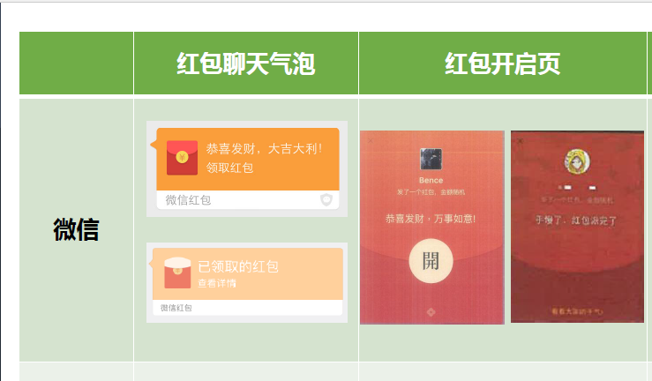

1.2 The Red Packet Chat Bubble and Red Packet Opening Pages of the alleged infringing ChuiNiu app

1.2.1 The Red Packet Chat Bubble of the ChuiNiu Red Packet (i.e. Pocket Money Red Packet) (the pages before and after the red packet is received)

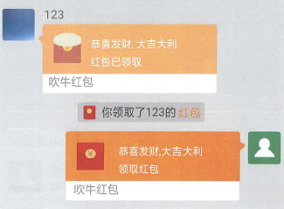

1.2.2 The Red Packet Chat Bubble of the Alipay Red Packet (the pages before and after the red packet is received)

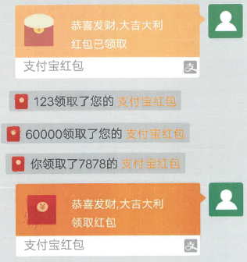

1.2.3 The Red Packet Chat Bubble of the Cloud Red Packet (the pages before and after the red packet is received)

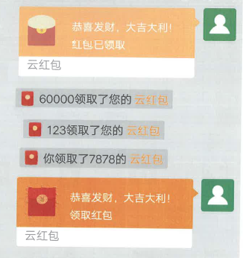

1.2.4 The Red Packet Opening Pages of the ChuiNiu Red Packet (i.e. Pocket Money Red Packet) (the pages before and after tapping)

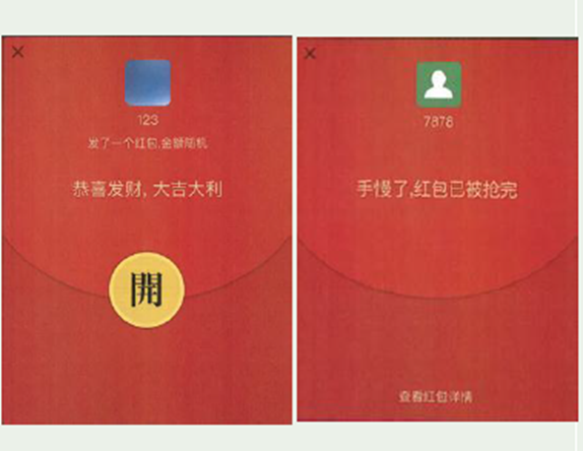

1.2.5 The Red Packet Opening Page of the Alipay Red Packet (the page before tapping)

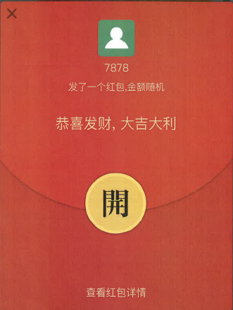

1.2.6 The Red Packet Opening Page of the Cloud Red Packet (the page before tapping)

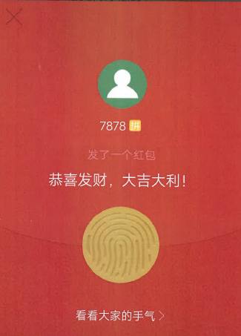

2. Relevant pages of the WeChat app that constitute “decoration of certain influence” as claimed by the plaintiffs and relevant pages in the ChuiNiu app which are alleged to have constituted unfair competition

2.1 Relevant pages of the WeChat app that constitute “decoration of certain influence” as claimed by the plaintiffs (including the relevant pages of the WeChat Red Packet and the overall page of WeChat)

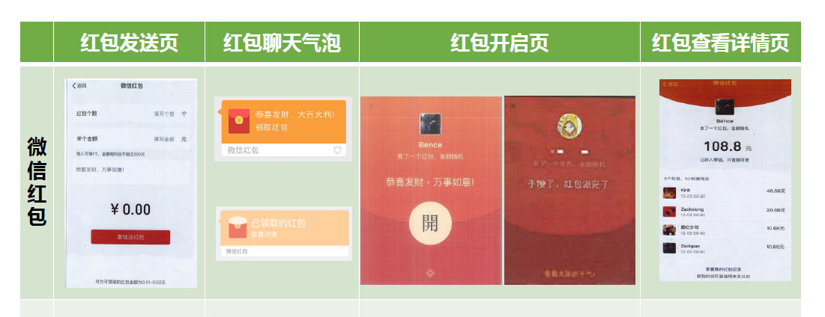

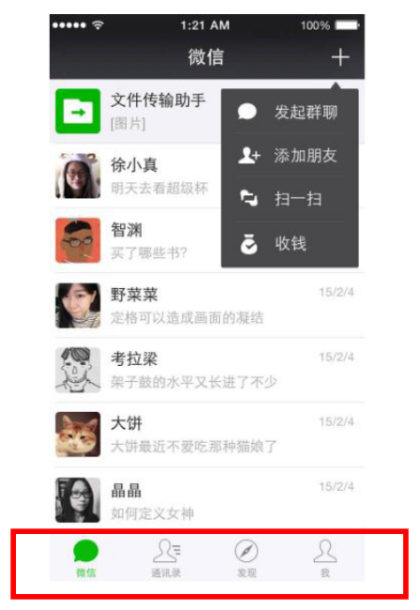

2.2 Relevant pages of the ChuiNiu app which are alleged to have constituted unfair competition

2.2.1 The Red Packet Sending Page of the ChuiNiu Red Packet (i.e. Pocket Money Red Packet)

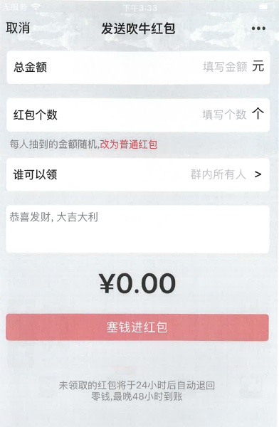

2.2.2 The Red Packet Sending Page of the Alipay Red Packet

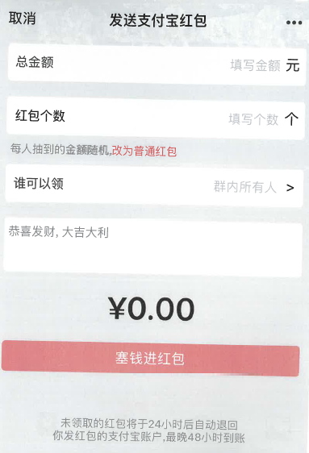

2.2.3 The Red Packet Sending Page of the Cloud Red Packet

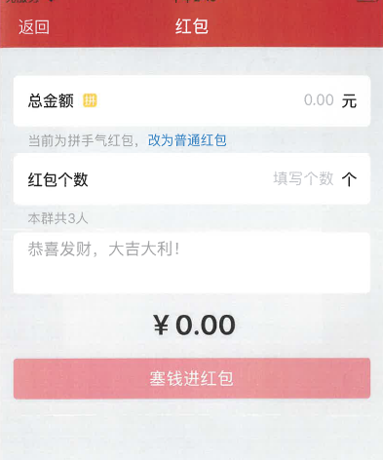

2.2.4 The Red Packet Chat Bubble and Red Packet Opening Pages the same as those in Annex 1.2

2.2.5 The Red Packet Detail Checking Page of the ChuiNiu Red Packet (i.e. Pocket Money Red Packet)

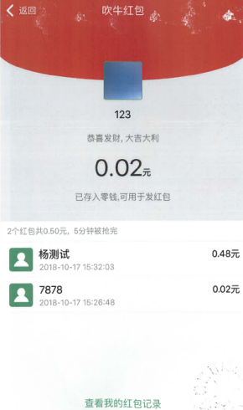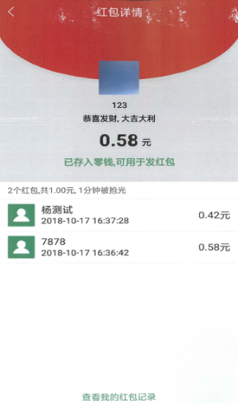

2.2.6 The Red Packet Detail Checking Page of the Alipay Red Packet

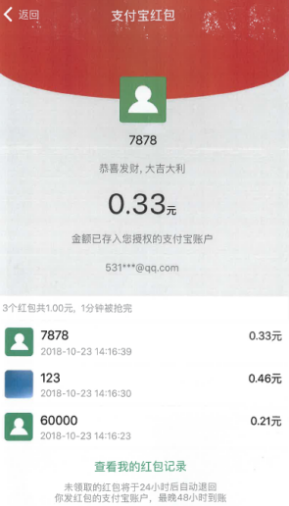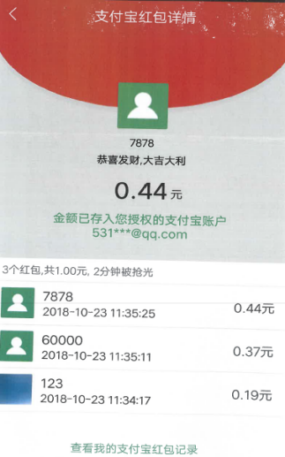

2.2.7 The Red Packet Detail Checking Page of the Cloud Red Packet

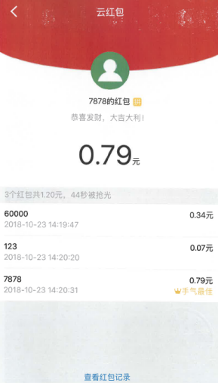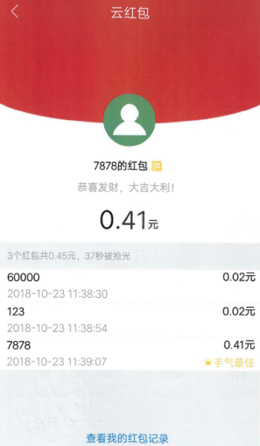

2.2.8 The overall page of the ChuiNiu app



